**Full Stack III - Lab 5.1**

* Pipes and File Streams.

**Node Reference**

An optional reference for Node JS: **https://www.w3schools.com/nodejs**

**Developer Note:**When working on your exercises, please create separate folder for your work. This way you won’t putting all your code in the same file, which can pollute the global namespace. In short, it will prevent you from overwriting your own work and causing your code to compile incorrectly.

Organize your folder structure in this way.

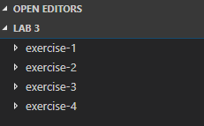

**NodeJs: File Streams and Piping**

**Exercise #1 – Readable Stream**

1. Open a command prompt create a directory for **exercise-1**
2. Open Visual Studio Code and open the folder **exercise-1**
3. Create a new file named **app.js** file.

Create a new text file named **data.txt.**

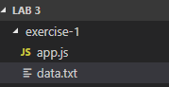

1. Open the data.txt and enter the following text in the file and save.

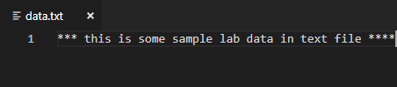

1. In the app.js, write the following code to create a readable stream to the data text file.

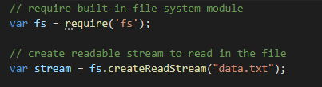

1. Readable stream inherits from the Event Emitter. Subscribe to the ‘data’ event and create a callback function to be called when data is received from the readable stream.

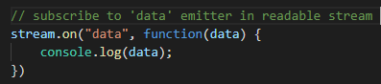

7. Run node app.js and the output will display the **buffer** value in memory.



8. Change the stream.on subscriber to do the following:

1. Convert the buffer value back to a string and output it to the console..

**[Expected Output]**



**Exercise #2 – Writable Stream**

1. Open a command prompt create a directory for **exercise-2**
2. Open Visual Studio Code and open the folder **exercise-2**
3. Create a new file named **writer.js** file.



1. Write the following code in the file to create a **writer module** to be exported. (Ignore comments in code below)

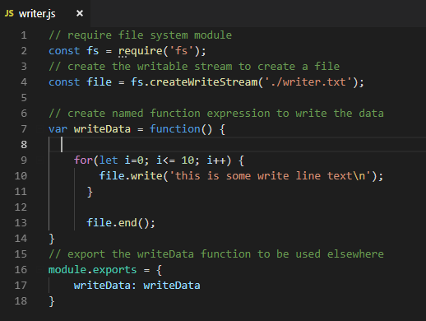

1. Create an **app.js** file and do the following:
   1. Use the **require** keyword to load the **writer.js module**.
   2. Invoke (call) the **writeData** method from the **writer.js module** to write the text to the file.
   3. Run the app.js at the command line.



The finished file structure should be as follows.

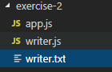

**[Expected Output]**

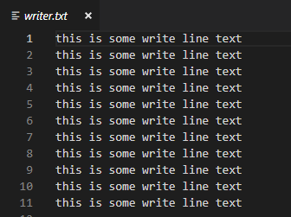

**Exercise #3 – Pipes**

1. Open a command prompt create a directory for **exercise-3**
2. Open Visual Studio Code and open the folder **exercise-3**
3. Create a new file named **pipes.js** file.



1. Install third party module named ‘request’ using the following command.



After the module is installed your directory will have this structure.

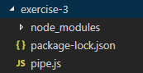

1. In pipe.js write the following code.

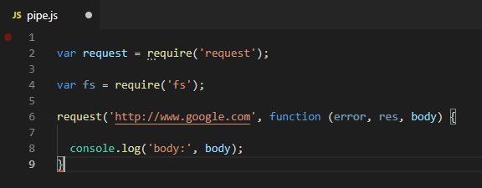

1. Run pipe.js file on the command line



Expected result is the html from the website will be outputted to console.

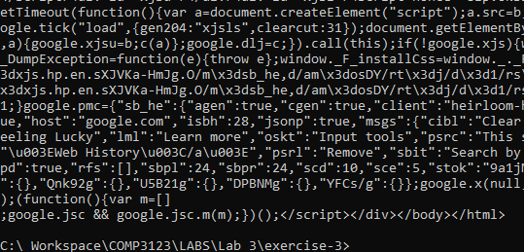

1. Read the documentation on the request module and pipe

<https://www.npmjs.com/package/request>

<https://nodejs.org/api/stream.html#stream_event_pipe>

8. Change the code to do the following:

1. The request object is by default a readable stream, use the pipe event on it
2. Chain the **pipe** into a **writeable stream that will write the HTML** into a file named output.html.

**[Expected Result]**

The directory should look as follows with a new file created named output.html

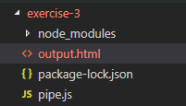

Inside the output.html should be the html from the request response.

